Individual Pathways
Activity 8.3
Analysing forces, energy and motion

- Over a 1-minute period of time, the position of a coach was plotted as she moved along the sideline during a netball game. Her position at 5-second intervals is shown in the table below. Assume that the coach started at the midline of the court.
Time (s) | Position (m)
0 | 0
5 | 3
10 | 6
15 | 6
20 | 6
25 | 7
30 | 8
35 | 9
40 | 10
45 | 10
50 | 8
55 | 4
60 | 0

- Use the values in the table to draw a position-time graph of the coach’s motion over the 1-minute interval.
- Use your graph from part (a) to help you draw a velocity-time graph of the coach’s motion for the interval.
- What quantity is represented by the gradient of your velocity-time graph? ……………………
- How does the velocity-time graph show that the coach’s displacement over the 1-minute interval is 0?
……………………………………………………………………………………………………………………………………………………………………………………………………
- Explain why the velocity time graph you have drawn is not a realistic representation of motion.
………………………………………………………………………………………………………………………………………………………………………………………………………………………………………………………………………………………………………

- The average polar bear runs at a top speed of 40 km/h. How far would it get at this speed if it ran for 10 minutes?
………………………………………………………………………………………………………………………………………………………………………………………………………………

- The ticker tape below shows the motion of a dynamics cart during an experiment. A ticker timer places 50 dots every second on the tape.

- What interval of time elapses between successive dots? …………………………………
- What period of time elapsed between points A and D? ………………………………
- In which intervals (A to B, B to C, or C to D) did the dynamics trolley:
- decelerate? Explain your answer. ………………………………………………………………………………………………………………………………………………………………………………………………
- remain at a constant speed? Explain your answer. ……………………………………………………………………………............................................................................................................................................................................

- Complete the following table.
Force | Mass | Acceleration
100 N |  | 18 km/h/s
 | 300 g | 4 m/s²
1.2 N | 2 kg

- A car is travelling down the highway at 90 km/h when a kangaroo bounces onto the road ahead. The driver takes 1.2 seconds to react and take his foot off the accelerator before braking hard.
- How far will the car travel during the time the driver is reacting? (This is called the reaction distance.)
…………………………………………………………………………………………………..
- The car’s brakes can slow the car at a rate of 6 m/s². How long will it take for the car to come to a complete stop?
……………………………………………………………………………………………………………………………………………………………………………………………………
- What force must be exerted by the brakes to stop the car if it has a mass of 1100 kg?
……………………………………………………………………………………………………………………………………………………………………………………………………
- The distance over which the car is brought to a stop by the brakes — the braking distance — is found using the equation: 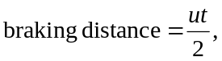
where u is the speed at which the car was travelling when braking commenced and t is the period of time taken for the car to stop. Use the equation to determine the car’s braking distance.
……………………………………………………………………………………………………………………………………………………………………………………………………
- The total stopping distance of the car is equal to the reaction distance added to the braking distance. Calculate the stopping distance of the car.
……………………………………………………………………………………………………………………………………………………………………………………………………
- Draw and label arrows on the diagram below to show the forces acting on the car during the deceleration.

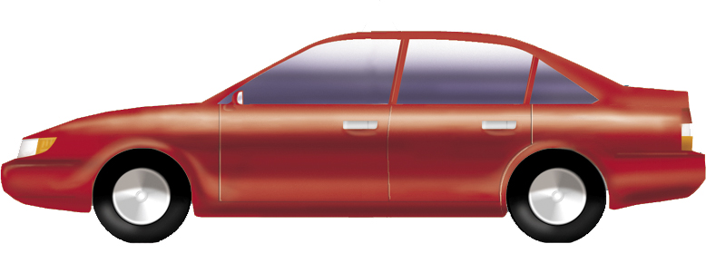

- Which two of the forces shown in your diagram are an example of an action-reaction pair?
…………………………………………………………………………………………………

- In which of the following cases is the most work done against gravity? Justify your answer.
- A 20 kg ball is dropped from a height of 3 metres
- A 60 kg student climbs up and down a 5-metre high flight of stairs
- A weightlifter holds a bar and weights with a mass of 150 kg at a height of 2.0 metres above the ground
- A 100 g chocolate bar is lifted up a distance of 40 cm from a tabletop.
……………………………………………………………………………………………………………………………………………………………………………………………………………………………………………………………………………………………………………………………………………………………………………………………………………………………………………………………………………………………………………

- A 90 kilogram skier catches a chairlift to the top of a 100-metre high hill then skies down the length of the 1200 metre slope.
- How much gravitational potential energy is gained by the skier as he is lifted to the top of the hill?
……………………………………………………………………………………………………………………………………………………………………………………………………
- As the skier comes down the slope, a frictional force of 40 N is exerted on the skis by the snow. How much kinetic energy does the skier have by the time he reaches the bottom of the slope?
………………………………………………………………………………………………………………………………………………………………………………………………………………………………………………………………………………………………………
- In what form has energy been transferred from the skier by the friction?
……………………………………………………………………………………………........
- Suggest at least two ways in which the skier can maximise the amount of kinetic energy that he retains at the bottom of the slope.
……………………………………………………………………………………………………………………………………………………………………………………………………

Answers

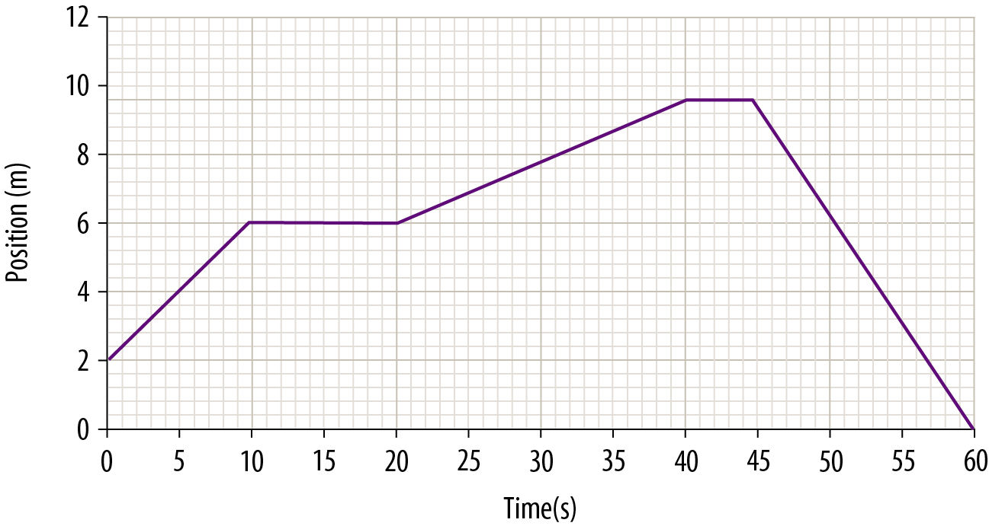

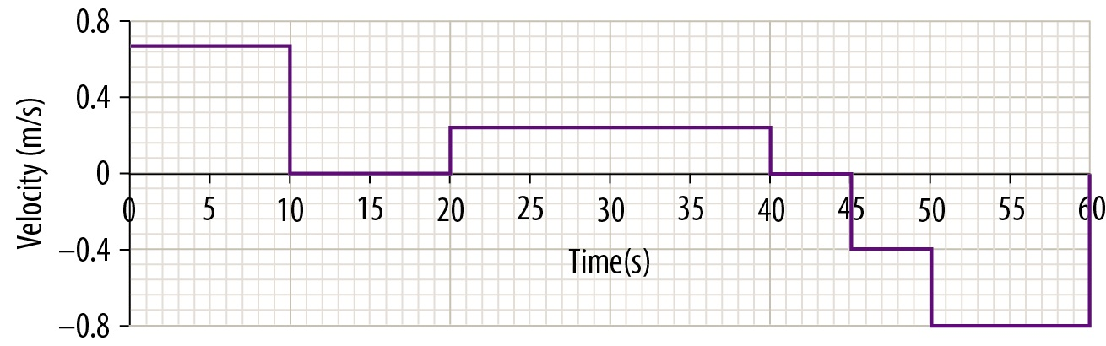

- Acceleration
- The area between the graph and the horizontal axis on a velocity-time graph represents the displacement. As the area above the axis is equal to that below the axis, the total displacement of the coach is shown to be equal to 0.
- The velocity changes in this graph happen instantly while in the real world there would be slopes representing acceleration and deceleration between the velocity changes.

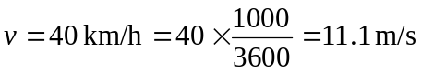
t = 10 minutes = 10 × 60 = 600 s
d = vt = 11.1 × 600 = 6 660 m

- 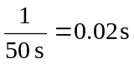
- 14 intervals × 0.02 s/interval = 0.28 s

- C to D: The distance between dots becomes progressively smaller, indicating that the speed of the trolley is decreasing.
- B to C: The distance between the dots remains uniform so the dynamics trolley would have been travelling at a constant speed.

Force | Mass | Acceleration
100 N | 20 kg | 18 k/h/s
1.2 N | 300 g | 4 m/s²
1.2 N | 2 kg | 0.6 m/s²

  - v = 90 km/h = 25 m/s
reaction distance = vt = 25 × 1.2 = 30 m
  - 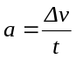
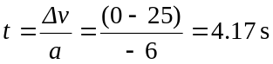
  - F = ma = 1100 × −6 = −6 600 N
  - 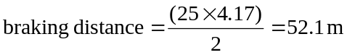
  - stopping distance = 30 + 52.1 = 82.1 m

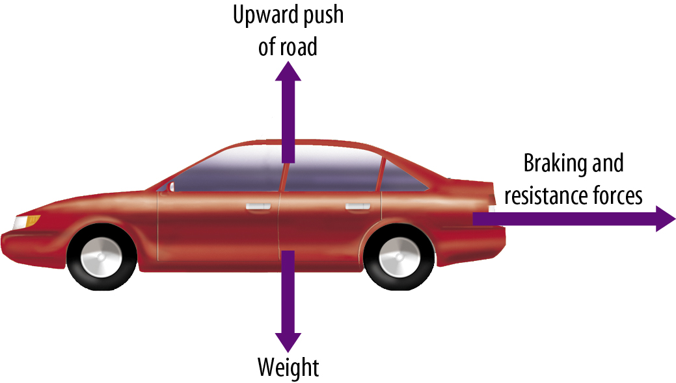
Note that while the car is braking and the accelerator is not being applied, there is no thrust force acting on the car.
  - Weight and the upward push of the road

- D, as it is the only case where work is done against gravity. In (a), work is done by gravity. In (b) and (c), no work is done as the total displacement is zero.

  - GPE = mgh = 90 × 9.8 × 100 = 88 200 J
  - Work done by friction = Fd = 40 × 1200 = 48 000 J
Kinetic energy = GPE – work = 88 200 – 48 000 = 40 200 Joules
  - Heat
  - Responses may include waxing skis to decrease friction, wearing a racing suit to reduce drag, and minimising body profile.

